Diary Entry

**1 .0 Introduction**

The team were required to develop a territorial acquisition game.

1.1 Materials

|  |  |
| --- | --- |
| Material | How the team used it |
| Google Docs | The team used Google Docs to create mock-up character cards (Table 1.1 – 1.4) and game cards (Table 2.1 – 2.4). |
| Paint | The team used paint to create a mock-up game board for the game (Figure 1). |

1.2 The Rules

The aim of the game is for the players to try and get to the end of board, whilst on their journey they need to defeat obstacles to acquire the different territories on the board.

* The players choose a player card (Tables 1.1 - 1.4)
* Players move around the board from event to event
* The event will have a power level and a attribute needed to beat it.
* At the obstacle players will decide if they want to attack it.
* To attack an event spot you need to roll a dice 3 times and add the rolls and the players own attribute score together if the number is bigger than the obstacle power they have claimed that location, if it is lower they die.
* If a player uses their best skill they miss 2 turns as they need to rest, if they use their worst skill they miss no turns, and is they use any other skill they miss 1 turn.
* The game finishes when the players have completed the board or have all died.
* The player who has the most locations wins the game.

1.3 Board and Player Cards

**Figure 1** – Picture of the design of the game board. [A] The start position, [B] The end position, [C] An example event spot.

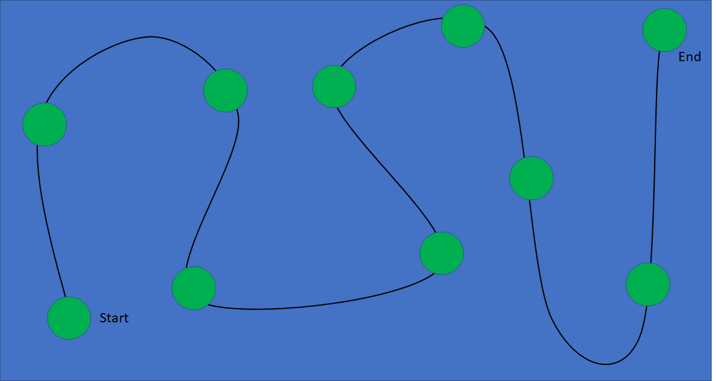

**C**

**A**

**B**

**Table 1.1** – A table showing the Soldier player card

|  |  |
| --- | --- |
| **Soldier** | **Attributes Values** |
| Combat | 8 |
| Healing | 2 |
| Spells | 1 |
| Negotiation | 4 |
| Courage | 10 |
| Defences | 5 |
| Agility | 5 |

**Table 1.2** – A table showing the Cleric player card

|  |  |
| --- | --- |
| **Cleric** | **Attributes Values** |
| Combat | 1 |
| Healing | 10 |
| Spells | 8 |
| Negotiation | 5 |
| Courage | 2 |
| Defence | 3 |
| Agility | 3 |

**Table 1.3** – A table showing the Cavalry player card

|  |  |
| --- | --- |
| **Cavalry** | **Attributes Values** |
| Combat | 7 |
| Healing | 3 |
| Spells | 1 |
| Negotiation | 3 |
| Courage | 7 |
| Defences | 5 |
| Agility | 10 |

**Table 1.4** – A table showing the Mage player card

|  |  |
| --- | --- |
| **Mage** | **Attributes Values** |
| Combat | 5 |
| Healing | 7 |
| Spells | 10 |
| Negotiation | 4 |
| Courage | 3 |
| Defences | 1 |
| Agility | 4 |

1.4 Play testing

The team were able to do internal play testing, from the play testing they discovered that if the player dies early into the game it can be quite boring for them, and they also found that in the later stages of the game some of the players did not have enough power. This meant that new game cards were made to counter these problems. The added a spell card (Table 2.1) that allows a player to be revived, and added multiple Equipment cards (Table 2.2 – 2.4) which allow the players to gain more power in certain areas.

**Table 2.1** – Spell card, Revival of the dead

|  |  |
| --- | --- |
| **Card Type** | **Spell Card** |
| Card Name | Revival of the dead |
| Card Ability | Choose one player who has died and revive them. This card can only be used once. |

**Table 2.2** – Equipment card, Heavy Shield

|  |  |
| --- | --- |
| **Card Type** | **Equipment Card** |
| Card Name | Heavy Shield |
| Card Ability | The holder of the shield gains +3 defence , +1 combat and -1 speed. |

**Table 2.3** – Equipment card, Flame Sword

|  |  |
| --- | --- |
| **Card Type** | **Equipment Card** |
| Card Name | Flame Sword |
| Card Ability | The wielder of the sword has +1 combat, +1 courage, +1 negotiation. |

**Table 2.3** – Equipment card, Ice Wand

|  |  |
| --- | --- |
| **Card Type** | **Equipment Card** |
| Card Name | Ice Wand |
| Card Ability | The user of the wand gets +2 spells, +1 combat and -1 healing. |

1.5 Reflection

Experience of working in a team to solve he problem –

The team on during the project had good communication between the different people, but the spent too much time designing the game, which resulted in it being overly complex and less specific to the project breif.

Next time the team needs to create a game that closer represents the target brief, and need to create a slightly less complex game so that it will be easier to create a working version of the game, so that more playtesting can be done to help improve the game mechanics.

1.6 Team Members

* James Wilson
* Muhammed Ubaid-Ul-Hassan ibn Zulfqar
* Jamie Smith